Notes Oct 26
IP address of LiDAR: 192.168.1.3
*Port 2112 also worked
Goal: Create a node that subscribes to the /scan topic and then print to the terminal to “not proceed” if there is an object within 1 meter between the field of -2 and 2 degrees.

Issues we fixed and how we went about it
- The biggest I noticed when testing was that from -135 degrees we were getting values, but then from 0 to 135 we were getting all zeros. I was trying to only detect values within a certain range and you can see below what happened.
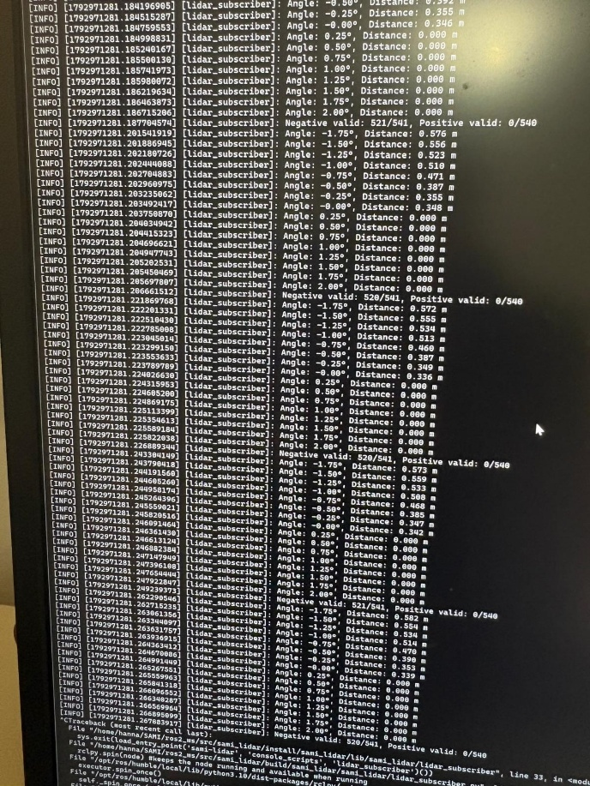
- I noticed that in Sopas the configuration of frequency and resolution was configured to 50 and 0.5. (NOTE: if you ever want to edit any of these click on Device à Login à authorized client à the password is client)
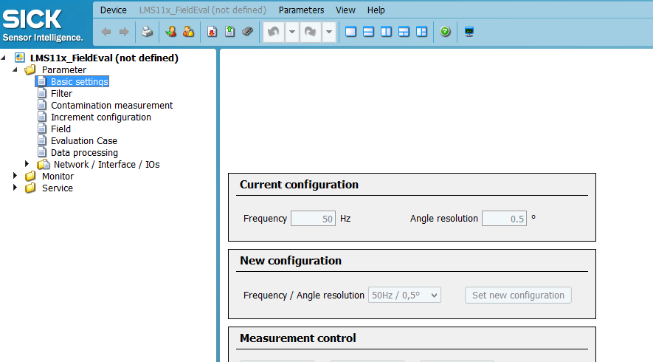
- But from above you can see that we were publishing 541 + 540, which is 1081, but at 50 hz we should and 0.5 resolution it should be 541 total.
- Eventually in LMS1xx.cpp by adding this print to terminal statement showed us that the LiDAR was only receiving 541 pieces of data. This confirmed that we were reading in the wrong frequency/resolution 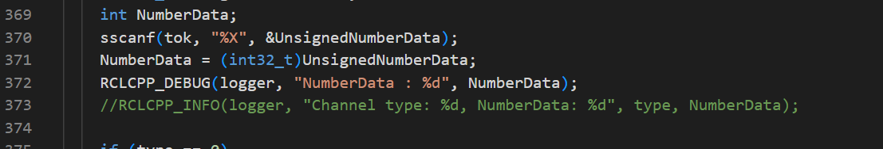
- Then in LMS1xx_node.cpp we printed the angular resolution, the configured scanning frequency and the configured angular resolution. This showed that we were correctly reading in the right configuration settings, but the wrong resolution.
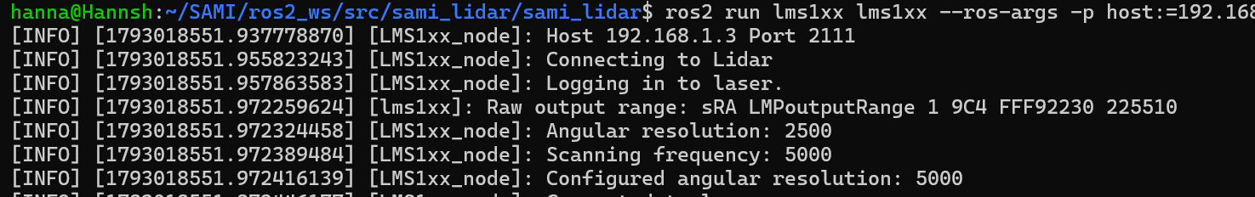
- Below in LMS1xx_node.cpp is where they calculate the range, angle increment, and min angle, which I was using in the subscriber. Originally for most of the calculations they were using outputRange_.angleResolution, which we learned was the wrong value. So then I changed anywhere where that variable was to cfg_.angleResolution and the solution was solved. The code is shown below
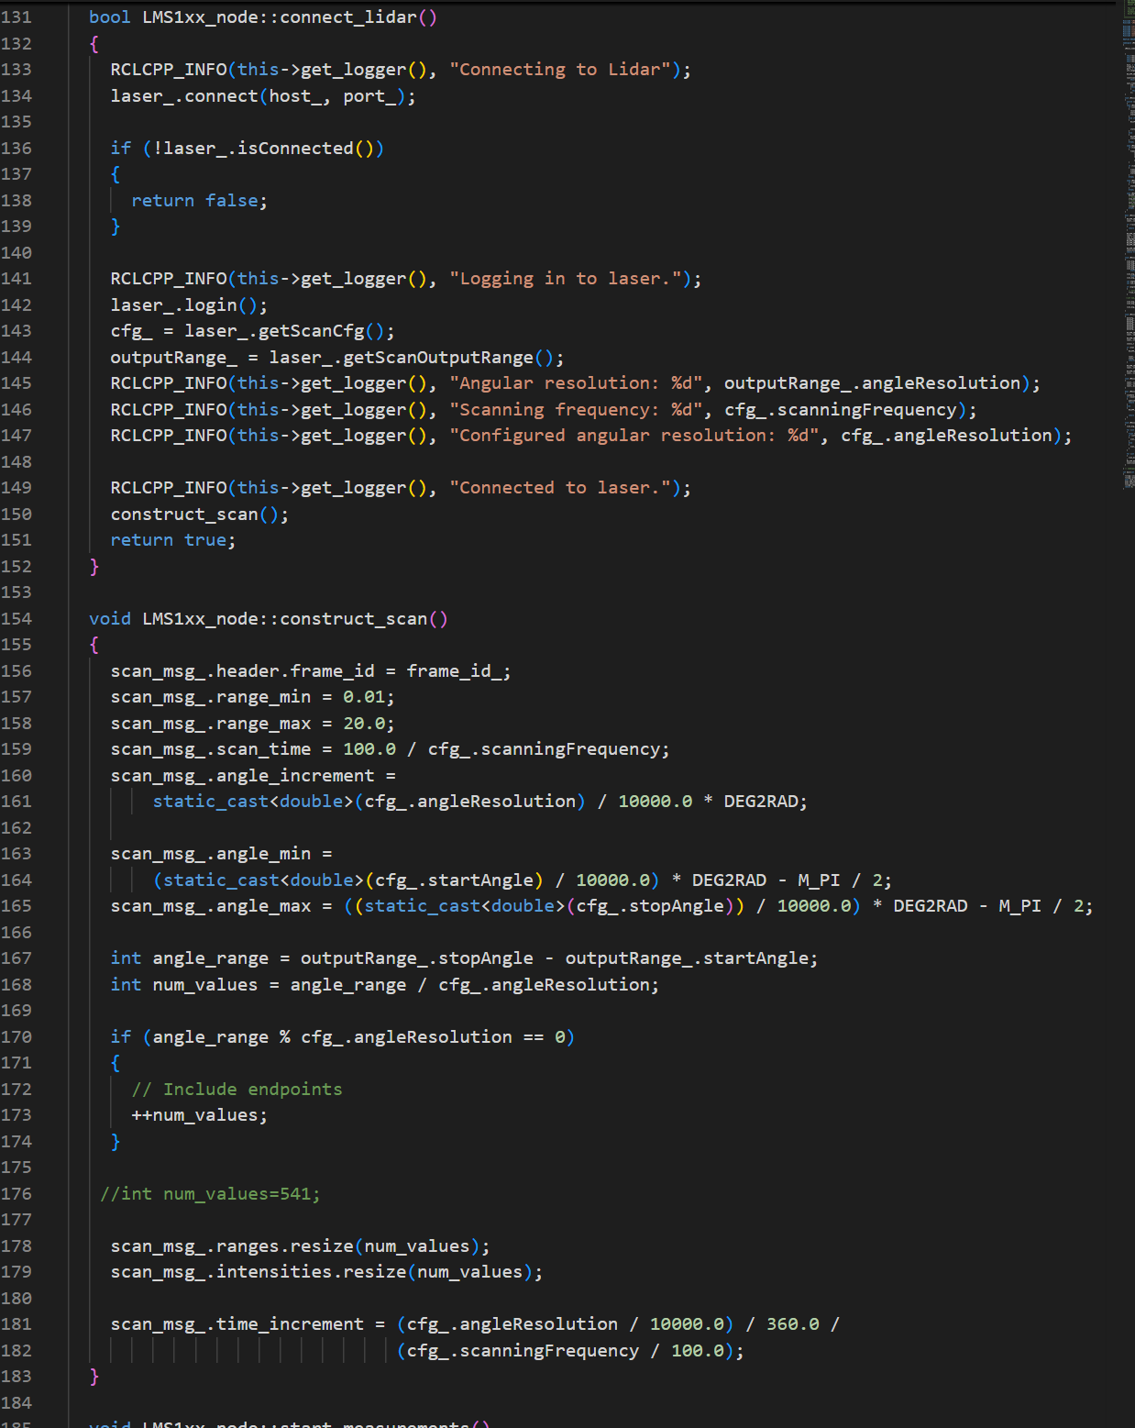
- Then I tested it and we were receiving 541 data points. I set a small range, (-2 degrees to 2 degrees) and printed to the terminal the distances all the variables were seeing. I put a measuring tape out and the LiDAR was accurate. If there was a value smaller than 1 m the LiDAR printed “Do not Proceed”
- IMPORTANT!: the data sheet says the LiDAR is good from like 0.5m to 10 or 20 m, but I was reading values in from 0.2 to 0.5, and they were also exact compared to what I measured with the ruler.

Before Oct 26:
Goal: Visualize the LiDAR data
- Determine the IP address of the LiDAR by using 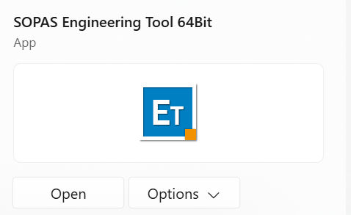
- Change the IP address of my computer to be on the same subnet as the LiDAR
- Run the publishing node (created by SICK which is lms1xx), and visualize the data in RVIZ.
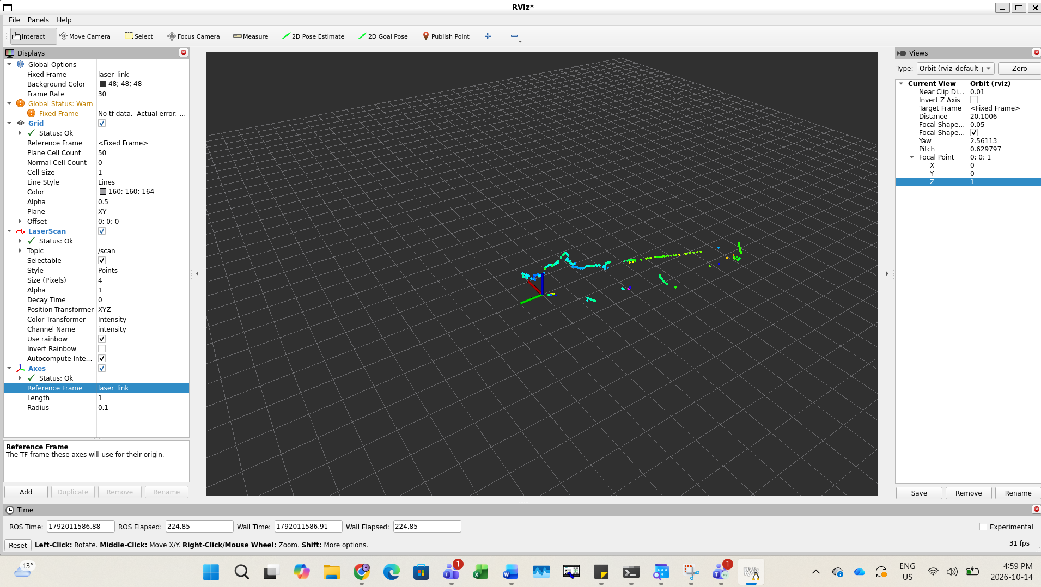
For RVIZ the biggest thing to note is that the Fixed Frame is: laser_link

grep -Rn "vector::_M_default_append\|resize(\|ranges.resize\|scan_time\|angle_increment" --include="*.cpp" --include="*.h" .

Summary: 1 package finished [6.16s]
hanna@Hannsh:~/SAMI/ros2_ws$ source install/setup.bash
hanna@Hannsh:~/SAMI/ros2_ws$ ros2 run lms1xx lms1xx --ros-args -p host:=192.168.1.3 -p port:=2111
[INFO] [1792981919.996395539] [LMS1xx_node]: Host 192.168.1.3 Port 2111
[INFO] [1792981920.007814597] [LMS1xx_node]: Connecting to Lidar
[INFO] [1792981920.010677035] [LMS1xx_node]: Logging in to laser.
[INFO] [1792981920.023369965] [lms1xx]: Raw output range: sRA LMPoutputRange 1 9C4 FFF92230 225510
[INFO] [1792981920.023523956] [LMS1xx_node]: Angular resolution: 2500
[INFO] [1792981920.023608612] [LMS1xx_node]: Scanning frequency: 5000
[INFO] [1792981920.023642427] [LMS1xx_node]: Configured angular resolution: 5000
[INFO] [1792981920.023673714] [LMS1xx_node]: Connected to laser.
[INFO] [1792981920.023692151] [LMS1xx_node]: Setting scan data configuration.
[INFO] [1792981920.027346255] [LMS1xx_node]: Starting scan measurement.
[INFO] [1792981920.046185182] [LMS1xx_node]: Starting device.
[INFO] [1792981920.049369573] [LMS1xx_node]: Commanding continuous measurements.

Origiginal code: void LMS1xx_node::construct_scan()
{
scan_msg_.header.frame_id = frame_id_;
scan_msg_.range_min = 0.01;
scan_msg_.range_max = 20.0;
scan_msg_.scan_time = 100.0 / cfg_.scanningFrequency;
scan_msg_.angle_increment =
static_cast<double>(outputRange_.angleResolution) / 10000.0 * DEG2RAD;

scan_msg_.angle_min =
(static_cast<double>(cfg_.startAngle) / 10000.0) * DEG2RAD - M_PI / 2;
scan_msg_.angle_max = ((static_cast<double>(cfg_.stopAngle)) / 10000.0) * DEG2RAD - M_PI / 2;

int angle_range = outputRange_.stopAngle - outputRange_.startAngle;
int num_values = angle_range / outputRange_.angleResolution;

if (angle_range % outputRange_.angleResolution == 0)
{
// Include endpoints
++num_values;
}

//int num_values=541;

New code:
{
scan_msg_.header.frame_id = frame_id_;
scan_msg_.range_min = 0.01;
scan_msg_.range_max = 20.0;
scan_msg_.scan_time = 100.0 / cfg_.scanningFrequency;
scan_msg_.angle_increment =
static_cast<double>(cfg_.angleResolution) / 10000.0 * DEG2RAD;

scan_msg_.angle_min =
(static_cast<double>(cfg_.startAngle) / 10000.0) * DEG2RAD - M_PI / 2;
scan_msg_.angle_max = ((static_cast<double>(cfg_.stopAngle)) / 10000.0) * DEG2RAD - M_PI / 2;

int angle_range = outputRange_.stopAngle - outputRange_.startAngle;
int num_values = angle_range / outputRange_.angleResolution;

if (angle_range % outputRange_.angleResolution == 0)
{

